Text Preprocessing in Twitter
- Overview
The vast majority of the social media data contains a rich amount of text data which are usually unstructured. The first step towards programmatically mining the useful information from the document is text preprocessing. In the SMILE application, we have included various text preprocessing steps such as word and sentence tokenization (break document into separate sentences or separate words), lemmatization, stemming, and part-of-speech tagging. All the generated results are open for download, and the user can perform their own quantitative analysis on their own term.
Tweets

Downloadable Results

Text Analysis Visualization

NLTK
This is generated when the user specifies a term to search in the "social media search" page and is saved on user's home directory.
The Python Natural Language Toolkit (NLTK library) has been used here.
Downloadable and visualization is available in the “Natural Language PreProcessing” web page.

Figure 1. Overall workflow of the text preprocessing

- Select data source to perform
The data fetched from twitter's RESTful API and our elasticsearch archive has been transformed to a tabular format (.csv) with each column represents a field, and each row represents an individual tweet/record. These data have been stored in the session folder under each user's home directory and the SMILE application creates an interface to interact with those data. In the “Natural Language PreProcessing" web page and under the configuration panel, there's a drop-down box named "select from your folder" which lists all the available Twitter data on disk; once a twitter file has been selected, a preview will appear with the columns which Text Preprocessing could be applied to (Figure 2).
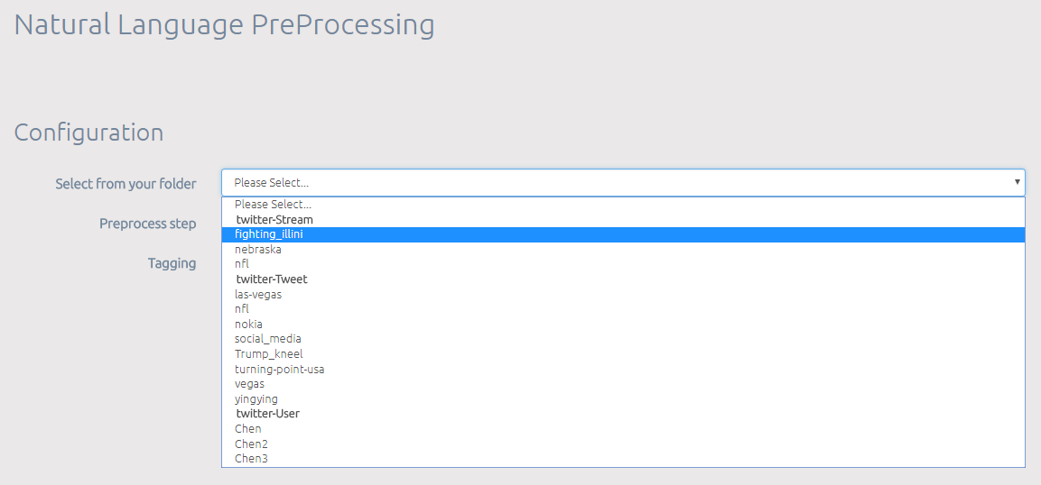
Select twitter data available to perform text preprocessing on

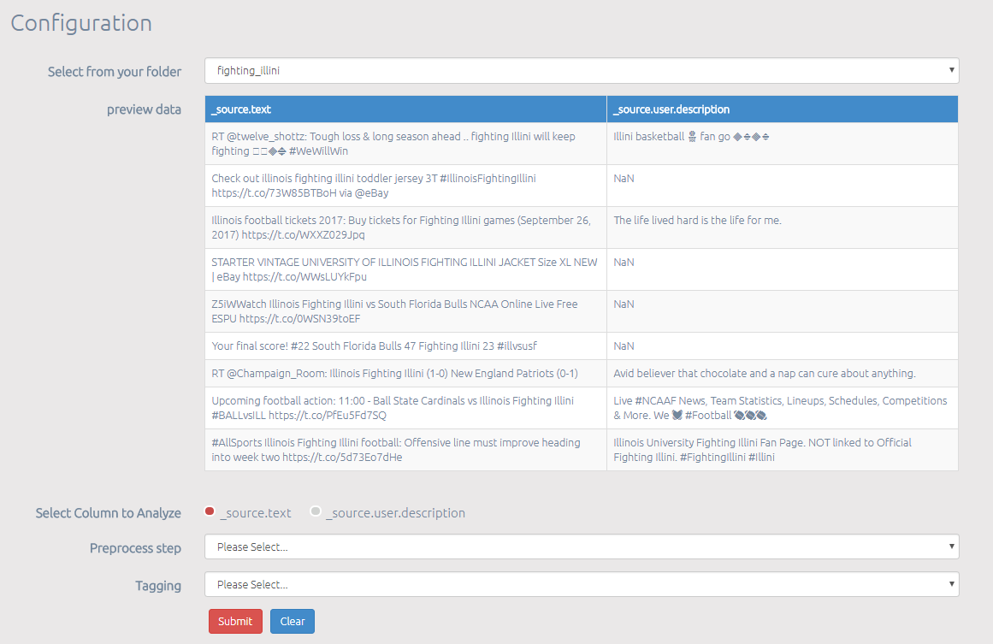
For tweets, you can choose to perform sentiment analysis on either “tweet text”, or on author’s description
Lemmatization and stemming available
Part-of-speech tagging available

Figure 2. Select twitter data and its field to perform Natural Language Preprocessing

- The list of the text preprocessing tasks
According to user's configuration, a few steps have been carried out by the SMILE application.
- Each line of text/tweet can be considered as a “sentence”. By separating a sentence using their punctuation, we break the sentence into phrases. Furthermore, we make sure the phrase qualifies by making sure it's not an empty string, does not only contain numeric values, and is not shorter than 20 letters. This collection of phrases will later be utilized to generate the “Word Tree” visualization.
- NLTK comes with a tweet tokenizer library that is built to break tweet into single words (unigram).
- Stop words removal is performed on the words generated from the previous step. The source of the stop words includes NLTK’s stopword list, an additional English stopword dictionary that has more coverage, as well as a dictionary of stopwords that customized for Twitter.
- All tokenized words are converted to lowercase.
- The user can specify to perform stemming, lemmatization, as well as both “stemming + lemmatization” on the tokenized words. The stemmed and lemmatized data will be saved in a .CSV file with each column as a processed word, and each row as a tweet/text record.
- Lemmatization refers to doing things properly with the use of a vocabulary and morphological analysis of words, normally aiming to remove inflectional endings only and to return the base or dictionary form of a word, which is known as the lemma. Here, WordNet’s built-in morphy function is being used and it will return the input word unchanged if it cannot be found in WordNet.
- Stemming usually refers to a crude heuristic process that chops off the ends of words and often includes the removal of derivational affixes. Porter stemming algorithm is being used in the SMILE application. It follows the algorithm presented in Porter, M. “An algorithm for suffix stripping.” Program 14.3 (1980): 130-137. Martin Porter, the algorithm’s inventor, maintains a web page about the algorithm at http://www.tartarus.org/~martin/PorterStemmer
- Part-of-speech (POS) tagging is available. POS tagging is the process of marking up a word in a text as corresponding to a particular part of speech, based on both its definition and its context, i.e. its relationship with adjacent and related words. The NLTK default POS tagger has been used, which essentially is an implementation of PerceptronTagger. The perceptron part-of-speech tagger implements part-of-speech tagging using the averaged, structured perceptron algorithm, and the default tagger uses the Penn Treebank Tag Set. Similar to stemming and lemmatization results, all the generated results will be saved in a .CSV file with the row as tweet/text record and the column as the tag of each word.
- Some basic statistical and linguistic visualization is available on the “Natural Language Preprocessing” web page. First of all, we plot “Top 25 most frequent words” in bar charts both for the raw tokenized words as well as for the lemmatized +/ stemmed words (Figure 3).
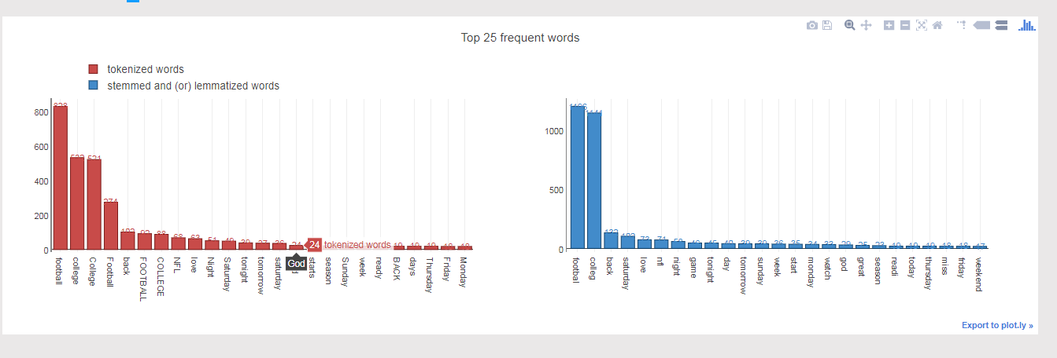
Figure 3. Word Distribution

- Another fun tool is the word tree, supported by Google Chart. It helps explore the text (corpus) and gain summary quickly (Figure 4). The word tree depicts a tree of phrases which is generated in by separating a sentence using their punctuation in the earlier preprocessing steps. The size of the words proportional to their usage. The more times a certain phrase occurs, the bigger font it will appear in. Try hovering over the words to see information about frequency.
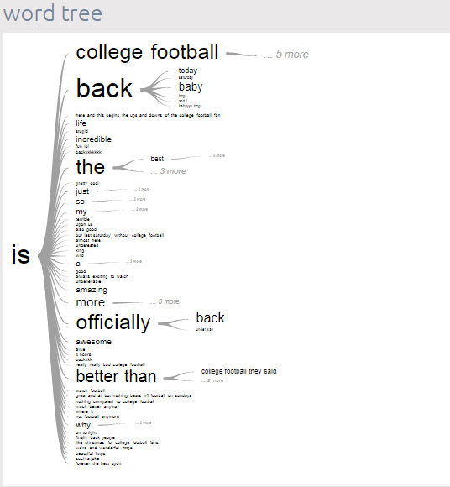
Figure 4. Word Tree

Vijayarani, S., Ilamathi, M. J., & Nithya, M. (2015). Preprocessing techniques for text mining-an overview. International Journal of Computer Science & Communication Networks, 5(1), 7-16.
https://sites.google.com/site/kevinbouge/stopwords-lists
https://sites.google.com/site/iamgongwei/home/sw
http://www.nltk.org/api/nltk.stem.html
https://nlp.stanford.edu/IR-book/html/htmledition/stemming-and-lemmatization-1.html
http://www.nltk.org/_modules/nltk/tag.html
http://web.mit.edu/6.863/www/PennTreebankTags.html
https://developers.google.com/chart/interactive/docs/gallery/wordtree

